PRISM: Portfolio Risk-aware Independent Set Meta-learning for Reproducible Memecoin Forecasting

Sanjan Baitalik^{a*}, Rajashik Dattaª, Sujaan Bhattacharyyaª, Sanket Ghoshª, Subhabrata Banerjee^{b}

^{a*}rayan.baitalik@gmail.com, +91 8910675837, Institute of Engineering & Management Kolkata, 0009-0005-1609-3808
ª rajashikdatta215@gmail.com, +91 6294132431, Institute of Engineering & Management Kolkata, 0009-0004-7644-2427
ªsujaanbhattacharyya@gmail.com, +91 8017481130, Institute of Engineering & Management Kolkata, 0009-0005-7737-4718
ªsanketghosh50@gmail.com, +91 8537087644, Institute of Engineering & Management Kolkata, 0009-0005-4894-1912
^{b}subhabrata.banerjee@iem.edu.in, +91 8017764037, Institute of Engineering & Management Kolkata

Abstract- Memecoin markets are difficult to forecast because short-lived community attention, abrupt narrative shifts, thin liquidity, and extreme volatility jointly influence price formation. However, existing forecasting research often treat such assets either as ordinary financial time series or as sentiment-driven assets without sufficiently integrating market behavior, social signals, cross-token dependence, diversification, and adaptive learning within a single reproducible framework. To address this gap, Portfolio Risk-aware Independent Set Meta-learning (PRISM) is presented in this article as a multimodal forecasting framework that combines sentiment-aware market modelling, risk-aware graph construction, maximal-independent-set-based token diversification, and meta-learning-based sequence adaptation. In the proposed pipeline, market variables and pre-aligned sentiment indicators are first organized into a deterministic data-to-forecast structure. Token relationships are then represented through a risk-aware graph so that correlated memecoin behavior can be captured, while maximal independent set selection is used to reduce redundant exposure among highly related tokens. Finally, a meta-learning forecaster is incorporated to support token-specific adaptation under heterogeneous and rapidly changing memecoin histories. The framework is evaluated against Persistence, Autoregressive Integrated Moving Average (ARIMA), Prophet, Random Forest, (eXtreme Gradient Boosting) XGBoost, Gated Recurrent Unit (GRU), and Long Short-Term Memory (LSTM) baselines under a controlled chronological protocol. The sensitivity of the proposed PRISM framework is further examined through parameter analysis over train ratios, lookback windows, graph-selection thresholds, and neural/meta-learning configurations. Overall, PRISM contributes a reproducible and interpretable evaluation framework for memecoin forecasting by combining multimodal signal fusion, graph-based diversification, adaptive forecasting, sequential ablation, robustness sweeps, and non-parametric statistical testing.

Keywords: Forecasting; Graph selection; Memecoin multimodal finance; Meta-learning; Reproducible evaluation; Sentiment analysis.

1. Introduction
Memecoin forecasting is treated in this study as a socio-financial time-series problem rather than as a conventional univariate price-prediction task. Price movements in these assets are driven by a mixture of liquidity, volatility, community attention, social-media sentiment, and short-lived cultural narratives. Therefore, any forecasting framework for this domain must be evaluated not only through predictive error, but also through preprocessing transparency, baseline strength, component-wise interpretability, and robustness under changing temporal settings.
The methodological foundation of the proposed PRISM framework can be traced to several established research directions. Mean-variance portfolio selection [1] formalized the importance of risk-aware diversification, but it was originally designed for conventional asset allocation and does not directly address highly volatile and socially driven memecoin behaviour. To model temporal dependence more effectively, Long Short-Term Memory networks [2] introduced gated recurrent learning for sequential data; however, standalone recurrent models do not explicitly incorporate portfolio risk, cross-token dependence, or social signals. Conditional Value-at-Risk optimization [3] further strengthened downside-risk modelling, but such risk measures alone do not provide a complete forecasting pipeline for multimodal crypto-market data. Since memecoin movements are strongly influenced by online discourse, VADER sentiment scoring [4] became relevant because it is designed for informal social-media text; nevertheless, sentiment scoring by itself cannot handle temporal adaptation or token-level dependency. Model-Agnostic Meta-Learning [5] addressed the problem of rapid task adaptation, but it does not specify how correlated financial assets should be selected or diversified before forecasting. Scalable additive forecasting through Prophet [6] provided a strong classical baseline for time-series modelling, but its structure is not designed to integrate graph-based diversification, sentiment-aware risk modelling, or meta-learning. Hence, these foundational studies motivate the need for a unified framework that can combine risk-aware selection, sentiment processing, temporal forecasting, and adaptive learning within a reproducible memecoin-specific pipeline.
Between 2020 and 2023, financial forecasting research increasingly emphasized deep sequence models and stronger benchmark design. N-BEATS [7] introduced a neural basis-expansion architecture for interpretable time-series forecasting and provided a strong benchmark for generic forecasting tasks; however, it does not explicitly model social attention, liquidity shocks, or token-network structure. To address probabilistic sequence forecasting more directly, DeepAR [8] developed autoregressive forecasting using recurrent networks and helped model uncertainty in time-series prediction. However, its general design does not directly solve the problem of correlated and narrative-driven memecoin behavior. In parallel, cryptocurrency risk-return analysis [9] empirically showed that digital assets exhibit distinctive financial behavior, but this work focused more on asset characteristics than on constructing adaptive forecasting systems. To extend neural forecasting into multi-horizon settings, Temporal Fusion Transformer [10] incorporated attention-based temporal modelling and interpretability mechanisms; however, its design is computationally heavier and does not inherently perform graph-based diversification among related assets. Informer [11] further improved long-sequence forecasting through efficient transformer attention, but it remains a sequence-modelling architecture rather than a complete multimodal and portfolio-aware crypto-forecasting framework.
The role of social signals in cryptocurrency prediction was later strengthened through Twitter sentiment and data-volume modelling [12], which showed that online attention can support Bitcoin trend prediction. However, the focus remained primarily on Bitcoin rather than memecoin-specific token universes. Extending this social-financial modelling direction, technical trading and social-media indicators with deep learning [13] demonstrated that market and social indicators can be jointly useful for cryptocurrency classification. Nevertheless, this approach does not explicitly address diversified support selection or meta-learning-based token adaptation. Memecoin connectedness analysis [14] then revealed that memecoins should not be treated as isolated speculative outliers, because their spillovers with larger cryptocurrencies can be material. This finding directly motivates the need to model cross-token relationships rather than relying only on independent token-wise forecasting. Deep recurrent cryptocurrency forecasting using LSTM, GRU, and bidirectional LSTM [15] provided important recurrent baselines, but such models still lack risk-aware graph selection and modular ablation-based validation. To address correlation control from a portfolio perspective, maximum-independent-set-based portfolio diversification [16] presented a graph-theoretic mechanism for reducing correlated exposure. However, it was not developed as a multimodal memecoin forecasting framework. These studies collectively indicate that sequence learning, sentiment modelling, and graph diversification are all relevant, but they are usually treated separately.
From 2024 onward, cryptocurrency forecasting and memecoin analytics became more explicitly multimodal. LLM and NLP-based cryptocurrency sentiment classification [17] compared language models for sentiment analysis and highlighted the growing role of language-based signals, but sentiment classification alone does not produce a complete token forecasting and evaluation pipeline. Building on the need to represent memecoins beyond price-only signals, Coin-Meme [18] modelled memecoins as cultural-financial objects by combining visual, textual, community, and market data. However, its emphasis on multimodal memecoin understanding does not directly provide a reproducible forecasting pipeline with chronological evaluation, graph diversification, and meta-learning adaptation. Extending the multimodal crypto-forecasting direction, deep-learning and NLP-based cryptocurrency forecasting [19] integrated financial, blockchain, and social-media signals and showed that multimodal crypto forecasting is feasible. However, it does not specifically address maximal-independent-set-based token diversification or component-wise ablation for memecoin forecasting. A review of deep learning for financial forecasting [20] also warned that many financial deep-learning studies overstate novelty when baseline strength, protocol transparency, and reproducibility are weak. This criticism is important for the present work because memecoin forecasting requires not only a proposed model, but also a clear evaluation design that explains how each component contributes.
Comprehensive research in 2025 further showed that cryptocurrency forecasting is moving toward hybrid, adaptive, and multimodal systems. Temporal Fusion Transformer-based multi-crypto trading [21] used on-chain and technical indicators within an attention-based forecasting and strategy framework, thereby showing the value of structured financial indicators for multi-asset crypto prediction. However, this approach remained focused on trading prediction and did not address risk-aware memecoin support diversification. To capture richer temporal patterns beyond attention-only modelling, transformer and parallel convolutional networks for cryptocurrency time-series prediction [22] combined transformer-based sequence learning with convolutional feature extraction. This helped the model capture both long-range temporal dependencies and local price-pattern variations. However, the method did not include sentiment-driven graph construction or maximal independent set filtering.
While these transformer-based models strengthened temporal representation learning, they still left the question of sentiment integration insufficiently addressed. In this direction, swarm-optimization-based sentiment fusion [23] showed that optimized sentiment integration can improve cryptocurrency price prediction. However, it did not combine sentiment fusion with meta-learning-based sequence adaptation or graph-based redundancy control. Similarly, tweet-sentiment evidence for cryptocurrencies [24] confirmed that social-media sentiment can influence crypto-market behaviour, but it mainly established sentiment as an important signal rather than proposing a complete multimodal forecasting architecture. The need to treat memecoins as multimodal cultural-financial objects was further emphasized by CoinCLIP [25], where multiple information channels were combined to assess Web3 memecoin viability. Although this work is highly relevant to memecoin analysis, viability assessment is different from reproducible short-horizon price forecasting with chronological testing, ablation, and statistical validation. Extending the adaptive forecasting direction, Adaptive Temporal Fusion Transformers for cryptocurrency price prediction [26] introduced an adaptive attention-based model for crypto-market forecasting. However, it did not explicitly combine portfolio risk awareness, independent-set token selection, and MAML-style token-specific adaptation. Thus, the 2025 literature strengthens the case for multimodal and adaptive forecasting, while still leaving space for a framework that integrates sentiment, graph diversification, and meta-learning within a reproducible memecoin-specific setting.
The 2026 literature further confirms the need for hybrid forecasting models with stronger validation. A hybrid SVR-based cryptocurrency forecasting and backtesting framework [27] combined support-vector regression with strategy evaluation, thereby showing the importance of linking forecasts with practical trading-oriented assessment. However, this framework did not address multimodal sentiment fusion or cross-token graph structure. Building further on the need for sentiment-aware forecasting, a unified GRU model with enhanced sentiment analysis [28] incorporated sentiment into recurrent cryptocurrency forecasting and harsh price-movement detection. Nevertheless, the method remained centred on recurrent sequence learning and did not include portfolio-risk-aware independent-set diversification. In a parallel direction, a hybrid transformer-based framework for multi-step Bitcoin forecasting [29] combined transformer-style representation learning with deep sequence modelling. This made the approach suitable for multi-step prediction in a major cryptocurrency setting. However, its focus on Bitcoin does not directly address the heterogeneous, thin-liquidity, and narrative-driven nature of memecoin token universes. Overall, these recent works show that the field is progressing toward hybrid and adaptive designs, but they also reveal a persistent gap: existing approaches rarely integrate market dynamics, social sentiment, cross-token dependence, diversification, and token-specific adaptation within one auditable evaluation protocol.
Motivated by the above literature survey, in this article PRISM is designed as a reproducible multimodal framework for memecoin forecasting rather than as a single black-box neural predictor. The framework is named Portfolio Risk-aware Independent Set Meta-learning because portfolio-style risk awareness, independent-set graph selection, and meta-learning adaptation are combined into a single data-to-forecast pipeline. In the proposed system, sentiment cues are fused with market variables, token relationships are represented through a risk-aware graph, redundant high-correlation neighborhoods are filtered using maximal independent set selection, and a MAML-enhanced LSTM forecaster is used for rapid token-specific adaptation. The main contributions of this work are therefore fourfold: first, a deterministic preprocessing and token-selection protocol is defined for the supplied memecoin database; second, a modular architecture is proposed in which sentiment fusion, risk-aware graph construction, MIS diversification, and MAML adaptation are separable and testable; third, a controlled comparison is performed against Persistence, ARIMA, Prophet, Random Forest, XGBoost, GRU, and LSTM baselines; and fourth, sequential ablation, parameter-sensitivity analysis, robustness sweeps, and paired Wilcoxon tests with Holm correction are used to ensure that the empirical claims are grounded in reproducible evidence.
The remainder of the paper is organized as follows. Section 2 describes the PRISM system architecture whereas Section 3 presents the algorithmic workflow. Dataset Construction and Preprocessing are explained in Section 4. Section 5 and Section 6 report exploratory data analysis & baseline characteristics and also formalizes the mathematical model respectively. Section 7 describes the results and analysis - experimental setup, baselines, and hyperparameters; sequential ablation. Finally, Section 8 concludes the study and outlines future work.

2. System Architecture
The system architecture with all the necessary components of PRISM has been visualized in Fig. 1 where the market features and sentiment fields are first aligned by timestamp and token identity. The aligned panel is then passed through deterministic filtering and scaling. A token-similarity graph is constructed from rolling-volatility and sentiment trajectories. The graph is used to select diversified token support neighborhoods through a maximal independent set rule. Finally, the selected support context is passed to a MAML-enhanced LSTM forecasting block, while the same data split is used for baselines, ablation variants, and robustness sweeps.

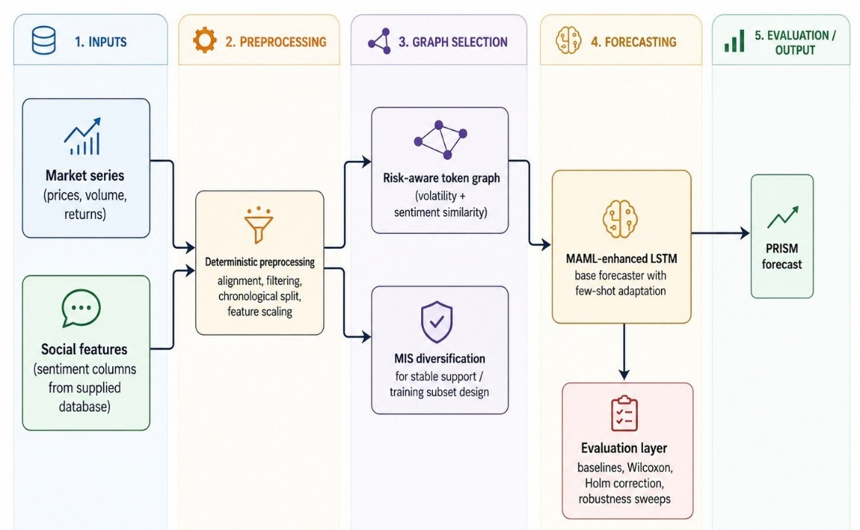
Fig. 1 System architecture

The presented architecture in the above figure is intentionally separated into preprocessing, graph selection, forecasting, and evaluation layers. This separation is done to make the pipeline more auditable because each module could be removed or added during ablation. It has also prevented the graph component from being treated as a black-box neural layer; instead, the graph is used for diversified support construction, and the neural model is kept responsible for sequence forecasting.

3. Algorithm
The PRISM algorithm is expressed as a compact implementation workflow. The workflow begins with sentiment normalization and trend estimation, moves through volatility and pairwise risk aggregation, constructs a confidence-weighted token graph, selects a diversified support subset through MIS, and then performs meta-learning-based forecasting and evaluation. The detailed workflow is shown below:

$$Begin$$
$$for each Memecoin M_{i}∈M do$$
$\text{SentimentScore}\left(M_{i}\right) =\frac{\text{VADER}\left(T_{M_{i}}\right)}{\min\left(\text{Volume}\left(M_{i}\right), \text{MarketCap}\left(M_{i}\right)\right)}$
$μ_{\text{Trend}}\left(M_{i}\right) = S\left(\text{SentimentScore}\left(M_{i}\right), β_{1}, β_{2}, β_{3}\right)$
$$end for$$
$$if (μ_{\text{Trend}}\left(M_{i}\right)≤τ_{\text{low}}) then$$
$Add{ M}_{i} to{ M}_{\text{reject}}$
$$else$$
$Add M_{i} to M_{\text{select}}$
$$end if$$

$$for each Memecoin M_{i}∈M do$$
$\text{Sim}\left(M_{i}\right)=\frac{k+1}{N_{\text{coins}}-1}⋅\text{Volatility}\left(M_{i}\right)-\frac{k}{N_{\text{coins}}-1}⋅\text{mean}\left(\text{Volatility}\left(D_{\text{train}}\right)\right)$
$γ_{\text{Risk}}\left(M_{i}\right)=S\left(\text{Sim}\left(M_{i}\right), β_{1}, β_{2}, β_{3}\right)$
$$end for$$
$$for each M_{i}∈M do$$
$for each M_{j}∈M do$
$μ_{G}\left(M_{i},M_{j}\right)=\min\left(μ_{\text{Trend}}\left(M_{i}\right),μ_{\text{Trend}}\left(M_{j}\right)\right)$
$γ_{G}\left(M_{i},M_{j}\right)=\max\left(γ_{\text{Risk}}\left(M_{i}\right),γ_{\text{Risk}}\left(M_{j}\right)\right)$
$end for$
$$end for$$
$$π_{G}\left(M_{i},M_{j}\right)=1-\left(μ_{G}\left(M_{i},M_{j}\right)+γ_{G}\left(M_{i},M_{j}\right)\right)$$
$$for each M_{i}∈M_{\text{select}} do$$
$if \text{rowsum}\left(π_{G}\left(M_{i}\right)\right)=0 then$
$Add M_{i} to M_{\text{volatile}}$
$Remove M_{i} from M_{\text{select}}$
$end if$
$$end for$$

$$G_{\text{Cluster}}=\text{BuildClusterGraph}\left(M_{\text{reject}}, M_{\text{select}}, M_{\text{volatile}}\right)$$
$$Select a subset of{ M}_{\text{volatile}} MIS. Add selected subset to M_{\text{select}}, \text{remaining to }M_{\text{reject}}$$
$$G_{\text{Updated}}=\text{UpdateClusterGraph}\left(G_{\text{Cluster}}, M_{\text{reject}}, M_{\text{select}}\right)$$
$$Output M_{\text{select}} as the optimal subset O_{\text{predict}}$$
$$for each M_{i}∈O_{\text{predict}} do$$
$L_{τ_{i}}\left(f_{θ}\right)=\frac{1}{N}\sum_{n=1}^{N}{{\left(v_{n}^{i}-f_{θ}\left(x_{n}^{i}\right)\right)}^{2}}$
$$end for$$
$$Meta-training:$$
$$\min_{θE_{τ_{i}∼p\left(τ\right)}}\left[L_{τ_{i}}\left(f_{θ}-α∇_{θL_{τ_{i}}}\right)\right]$$
$$for each{ M}_{i}∈O_{\text{predict}} do$$
$θ_{i}^{'}=θ-α ∇_{θL_{τ_{i}}}\left(f_{θ}\right)$
$\hat{y_{t}}=o_{t} ⊙ \tanh\left(c_{t}\right), o_{t}=σ\left(W_{o}⋅\left[ h_{t-1}, x_{t} \right]+b_{o}\right)$
$$end for$$
$$End$$

From the proposed algorithm it has been clarified that PRISM is not a single neural block but a staged pipeline. Its main methodological dependency is the ordering of sentiment normalization, graph diversification, and meta-learning adaptation. This ordering is important because graph selection is performed before forecasting, which reduces the risk that correlated token neighborhoods will dominate the support set used by the adaptive sequence model.

4. Dataset Construction and Preprocessing
The experimental dataset is prepared from a structured memecoin workbook containing token-wise market and sentiment information. Each sheet corresponds to a candidate token and includes market-related and sentiment-related fields [18], [19], [25]. Sheets are filtered by minimum history length and target availability. A deterministic modeling subset [20] is then selected by ranking eligible tokens according to available rows and lexical sheet order. This rule made the subset reproducible and prevented manual selection of favorable tokens.
The main target is a short-horizon future price value [12], [13], [19], [21]. Timestamps are normalized, rows with unusable target values are removed, numerical covariates are scaled from training-period statistics, and pre-aligned sentiment columns are retained without additional manual annotation [17]. The main split is chronological [6], [10], [20], so the earliest observations are used for training and the latest observations are used for testing. This split is adopted because non-stationary financial series must be evaluated without look-ahead leakage and temporal causality should be preserved in any deployable forecasting protocol [27]. The dataset summary containing detailed information about each memecoin token’s property has been presented in Table 1.
Table 1. Dataset Summary of different memecoin token
Item | Value
Candidate token sheets | 1,273
Eligible sheets after filtering | 881
Deterministic modelled subset | 200 tokens
Processed aligned observations | 60,431 rows
Mean modelled token history length | 302.16 aligned observations/token
Approximate median modelled token history length | 302 aligned observations/token
Main chronological train ratio | 0.8
Forecast horizon | 3 days
Default lookback window | 14 days
Random seeds | 11, 17, 23
Robustness grid | train ratios {0.7, 0.8, 0.9}; lookbacks {7, 14, 21}

Table 1 shows that a broad candidate universe is reduced to a deterministic modeling panel. The reduction has not been used to create a hand-picked subset rather it is used to keep the experimental budget controlled while preserving traceability. The mean and median history lengths indicate that the final panel is approximately balanced after alignment, although token-level volatility and error behavior remained heterogeneous. The robustness grid is included to avoid dependence on a single favorable chronological split or lookback setting [20], [27].

5. Exploratory Data Analysis and Baseline Characteristics
In this section the processed panel is explored before model comparison so that baseline characteristics could be documented. The descriptive statistics are treated as an interpretive layer rather than as a model-selection tool. Since memecoin prices frequently contain extreme micro-price values and abrupt jumps, mean-only summaries are expected to be unstable [9], [14]. Median, interquartile range, and range values are therefore used wherever such exports are available. The baseline characteristics are used to analyze the memecoins are shown in Table 2.
Table 2 Baseline characteristics
Quantity | N | Mean | SD | Median | Q1 | Q3 | Range
Token history length | 200 | 302.16 | – | 302.00 | – | – | panel-derived
MAE across tokens | 96 | 0.1443 | 1.2467 | 0.0009 | 0.0001 | 0.0026 | 0–12.1966
RMSE across tokens | 96 | 0.1727 | 1.5141 | 0.0011 | 0.0001 | 0.0026 | 0–14.8213
Directional accuracy (%) | 95 | 49.5033 | 22.0983 | 50.0000 | 40.0000 | 59.4118 | 0–100
Hit rate (%) | 96 | 8.5794 | 18.7909 | 0.0000 | 0.0000 | 11.1111 | 0–100
ROI (%) | 95 | 813.8445 | 7948.67 | -3.8041 | -16.6545 | 0.0000 | -88.1553–77471.14
Sentiment score support | token-date | bounded | – | centered by aggregation | negative | positive | -1–1

From Table 2 it is observed that the token universe is highly skewed. ROI and error ranges are dominated by a small number of extreme tokens, while median errors are much smaller than mean errors. This pattern justifies the use of non-parametric paired testing and conservative interpretation of aggregate means. Sentiment scores are retained as bounded, time-aligned token-date features rather than collapsed into a single global class count [17], because sentiment is used as a dynamic covariate in forecasting rather than as a static token label.

6. Mathematical Model
Let $M=\{M_{1},…,M_{N}\}$ denotes the modelled token universe. For token $M_{i}$ at time $t$, the market subvector, sentiment subvector, and auxiliary liquidity/volatility indicators are represented by $p_{i,t}$, $s_{i,t}$, and $q_{i,t}$, respectively. The fused state is defined in equation (1) [12], [19], [21]:
$z_{i,t}=\left[ϕ_{p}\left(p_{i,t}\right); λ_{t}ϕ_{s}\left(s_{i,t}\right); ϕ_{q}\left(q_{i,t}\right)\right], λ_{t}=\frac{1}{1+exp\left(-ω^{⊤}q_{i,t}\right)}$ (1)
In Equation (1), $ϕ_{p}\left(⋅\right)$, $ϕ_{s}\left(⋅\right)$, and $ϕ_{q}\left(⋅\right)$ denote scale-normalizing transformations, while $λ_{t}$ controls the effective sentiment weight under changing liquidity conditions. When raw text sentiment is available, a liquidity-normalized VADER sentiment score is computed through equation (2) [4], [12], [17], [24]:
$S_{i}\left(t\right)=\frac{VADER\left(T_{i,t}\right)}{ϵ+min\{log\left(1+V_{i,t}\right),log\left(1+C_{i,t}\right)\}}$ (2)
Here, $T_{i,t}$ denotes token-specific social text, $V_{i,t}$ denotes trading volume, $C_{i,t}$ signifies market capitalization, and $ϵ$ prevents numerical instability. The trend score is then computed as a regularized nonlinear score in equation (3) [9], [12], [19], [23]:
$μ_{i}\left(t\right)=β_{0}+β_{1}S_{i}\left(t\right)+β_{2}σ_{i}\left(t\right)+β_{3}m_{i}\left(t\right)+β_{4}S_{i}\left(t\right)σ_{i}\left(t\right)-ρ∥β∥_{2}^{2}+ε_{i,t}$ (3)
In equation (3), $σ_{i}\left(t\right)$ is rolling volatility and $m_{i}\left(t\right)$ is a momentum feature. The interaction term allows sentiment to have stronger or weaker effects under different volatility regimes. Pairwise token similarity is computed through equation (4) [1], [3], [9], [16]:
${Sim}_{ij}=αρ_{c}\left(σ_{i},σ_{j}\right)+\left(1-α\right)ρ_{c}\left(S_{i},S_{j}\right)-δ\frac{\left|{\overset{‾}{σ}}_{i}-{\overset{‾}{σ}}_{j}\right|}{{\overset{‾}{σ}}_{i}+{\overset{‾}{σ}}_{j}+ϵ}$ (4)
The above equation preserves the original volatility/sentiment similarity idea but penalizes pairs whose average volatility levels are very different. A token-level risk score is defined by equation (5) [3], [9], [14]:
$γ_{i}\left(t\right)=sigmoid\left(η_{0}+η_{1}σ_{i}\left(t\right)+η_{2}σ_{i}^{2}\left(t\right)+η_{3}log\left(1+\left|d_{i}\left(t\right)\right|\right)\right)$ (5)
Here, $d_{i}\left(t\right)$ denotes a drawdown or deviation-from-baseline term. Now, pairwise trend and risk aggregation are calculated and represented by equation (6) [1], [3], [16]:
$μ_{g}\left(i,j\right)=min\{μ_{i},μ_{j}\}-κ_{μ}\left|μ_{i}-μ_{j}\right|, γ_{g}\left(i,j\right)=max\{γ_{i},γ_{j}\}+κ_{γ}\left|γ_{i}-γ_{j}\right|$ (6)
Moreover, for construction of graph the required confidence score is calculated using equation (7):
$π_{g}\left(i,j\right)={\left[1-w_{μ}\left(1-{\tilde{μ}}_{g}\left(i,j\right)\right)-w_{γ}{\tilde{γ}}_{g}\left(i,j\right)\right]}_{0}^{1}$ (7)
In equation (7) [1], [3], [16], ${\left[x\right]}_{0}^{1}=min\{1,max\{0,x\}\}$ clips confidence to the unit interval. Now, the graph adjacency matrix is defined by Equation (8) [16], [25]:
$A_{ij}=I\left(i≠j\right)I\left(π_{g}\left(i,j\right)>τ_{edge}\right), G=\left(M,E\right), E=\{\left(i,j\right):A_{ij}=1\}$ (8)
Thereafter, a diversified support subset is obtained through the MIS program in equation (9) [16]:
$\max_{y∈\{0,1\}^{N}}\sum_{i=1}^{N}{y_{i}}u_{i} \text{s.t.} y_{i}+y_{j}≤1 ∀\left(i,j\right)∈E, O_{predict}=\{M_{i}:y_{i}=1\}$ (9)
The forecasting loss for token task $τ_{i}$ is computed through equation (10) [2], [5], [15]:
Lτifθ=1Dix,y∈Di​wty-fθx2+λθ∥θ∥22 (10)
MAML adaptation is then performed using the inner-loop update in equation (11) [5] and the outer-loop meta-update is represented in equation (12) [5].
$θ_{i}'=θ-α∇_{θ}L_{τ_{i}}^{train}\left(f_{θ}\right)$ (11)
θ←θ-β∇θi​Lτivalfθi' (12)
Finally, the LSTM forecast is produced through equation (13) [2], [15], [28].
${\hat{y}}_{i,t+h}=W_{y}\left(o_{t}⊙tanh\left(c_{t}\right)\right)+b_{y}, o_{t}=σ\left(W_{o}\left[h_{t-1},z_{i,t}\right]+b_{o}\right)$ (13)
From equations (1-13) it has been seen that how PRISM is defined as a modular forecasting system. Sentiment normalization and trend-risk scoring are used to build the graph whereas the MIS program is used to diversify support selection and finally the MAML-LSTM block is used to adapt sequence forecasts to token-specific histories.

7. Results and Discussion

7.1. Experimental Setup, Baselines and Hyperparameters
In the main experiment a chronological 80:20 train-test split [6], [10], [20], a 14-day lookback, a 3-day forecasting horizon, and three random seeds have been used. The chronological split is selected because non-stationary financial series must be evaluated without data leakage [20] and also as because of future observations cannot be used to tune models intended for deployment. Robustness sweeps are performed over train ratios $\{0.7,0.8,0.9\}$ and lookback windows $\{7,14,21\}$ [27].
The comparison suite consists of Persistence, ARIMA, Prophet, Random Forest, XGBoost, GRU, and LSTM baselines. Persistence is included as a naive short-horizon benchmark, while ARIMA is included as a classical statistical time-series model. Prophet is included as a scalable additive forecasting baseline [6] whereas Random Forest and XGBoost are included as nonlinear tree-based and boosted-regression models respectively. GRU and LSTM are also included as recurrent neural baselines [2]. However, the exported execution registry is used to mark the recurrent rows as surrogate/fallback backends, so their interpretation is kept conservative. The comprehensive summary of the hyperparameters used in the experimentation has been presented in Table 3.
Table 3. Hyperparameter summary
Setting | Value
Optimizer / learning rate | Adam / 0.001
Batch size / epochs / early stopping | 64 / 200 / patience 20
MAML inner steps / outer steps / inner LR | 5 / 200 / 0.01
Graph threshold / volatility window | 0.5 / 14 days
Main train ratio / lookback / horizon | 0.8 / 14 days / 3 days
Random seeds | 11, 17, 23
Significance test | paired Wilcoxon signed-rank test
Multiple-testing correction | Holm correction at $α=0.05$
Robustness grid | train ratios $\{0.7,0.8,0.9\}$; lookbacks $\{7,14,21\}$
Cautionary baseline notes | GRU and LSTM rows are exported through documented surrogate backends

From Table 3, it has been observed that the experimental protocol fixes the main chronological split while varying train ratios and lookback windows during robustness analysis. The setup is designed to limit favorable-split bias by keeping the main chronological split fixed while varying train ratios and lookbacks in the robustness grid. Table 3 summarizes the hyperparameters and evaluation settings used in the main experiment. The above table is also used to distinguish the fully implemented baselines from the documented recurrent fallback rows.

7.2. Sequential Ablation and Incremental Contribution Analysis
In this section, a sequential ablation analysis is conducted to determine whether the performance of PRISM is produced by the complete framework or by a single dominant component. In this evaluation, each variant is constructed by adding one modelling stage at a time while the same token subset, chronological split, forecast horizon, and evaluation protocol are preserved. This design allows the marginal contribution of sentiment fusion, graph-based diversification, and MAML-based adaptation to be examined under controlled conditions. The component-wise ablation of PRISM has been shown in details in Table 4.

Table 4. Sequential Component-wise Ablation of PRISM
Variant | Description | Mean MAE | Mean RMSE | Holm-corrected result
V0 | Price-only LSTM | 4.0539 | 4.7381 | –
V1 | V0 + sentiment fusion | 0.6981 | 0.7186 | V1 > V0, $p<{10}^{-12}$
V2 | V1 + graph + MIS diversification | 0.3005 | 0.3082 | V2 > V1, $p<{10}^{-40}$
V3 | Full PRISM + MAML adaptation | 0.1231 | 0.1479 | V3 > V2, $p<{10}^{-40}$

Table 4 presents the incremental evolution of PRISM from a reduced price-only sequence model to the complete Portfolio Risk-aware Independent Set Meta-learning framework. The first configuration, V0, is defined as a price-only LSTM model and produces a mean MAE of 4.0539 and a mean RMSE of 4.7381. These values indicate that price-only temporal modelling is insufficient for highly speculative memecoin markets, where short-term price formation is strongly influenced by social attention, liquidity shifts, and volatility clustering.
After sentiment fusion is added in V1, mean MAE is reduced from 4.0539 to 0.6981, while mean RMSE is reduced from 4.7381 to 0.7186. This stage represents the largest single-stage improvement in the ablation pathway, with an approximate 82.8% reduction in MAE and 84.8% reduction in RMSE relative to V0. The result suggests that sentiment information contributes substantially to forecast stability because memecoin prices are often shaped by community attention and rapidly changing market narratives.
Moreover, the V2 configuration is obtained by adding risk-aware graph construction and MIS-based diversification [1], [3], [9] to the sentiment-enhanced model. Mean MAE is reduced further from 0.6981 to 0.3005, and mean RMSE is reduced from 0.7186 to 0.3082. This improvement shows that the graph module is not merely added as structural complexity, but is used to control redundant exposure among highly correlated or behaviourally similar tokens. Through MIS-based selection, diversified token relationships are retained, while the influence of unstable token clusters is reduced.
Additionally, the full PRISM configuration, V3, is completed by introducing the MAML adaptation stage [5] and achieves the lowest error within the ablation sequence, with a mean MAE of 0.1231 and a mean RMSE of 0.1479. Relative to V2, this final stage reduces MAE by approximately 59.0% and RMSE by approximately 52.0%. Relative to the original V0 configuration, the complete framework achieves an approximate 97.0% reduction in MAE and 96.9% reduction in RMSE. These gains demonstrate that the proposed method is not dependent on a single isolated module; instead, progressively stronger performance is obtained as multimodal fusion, graph-aware diversification, and task-adaptive learning are combined.
The Holm-corrected significance results further strengthen this interpretation because each successive improvement is statistically supported. The transition from V0 to V1 confirms the importance of sentiment fusion, the transition from V1 to V2 confirms the value of risk-aware graph selection, and the transition from V2 to V3 confirms the additional benefit of meta-learning adaptation. Since all ablation variants are evaluated under the same deterministic protocol, the observed monotonic improvement provides direct evidence that PRISM’s superior performance over its reduced variants is caused by the cumulative contribution of its proposed components. Fig. 2 provides the graphical visualization of the ablation results reported in Table 4.

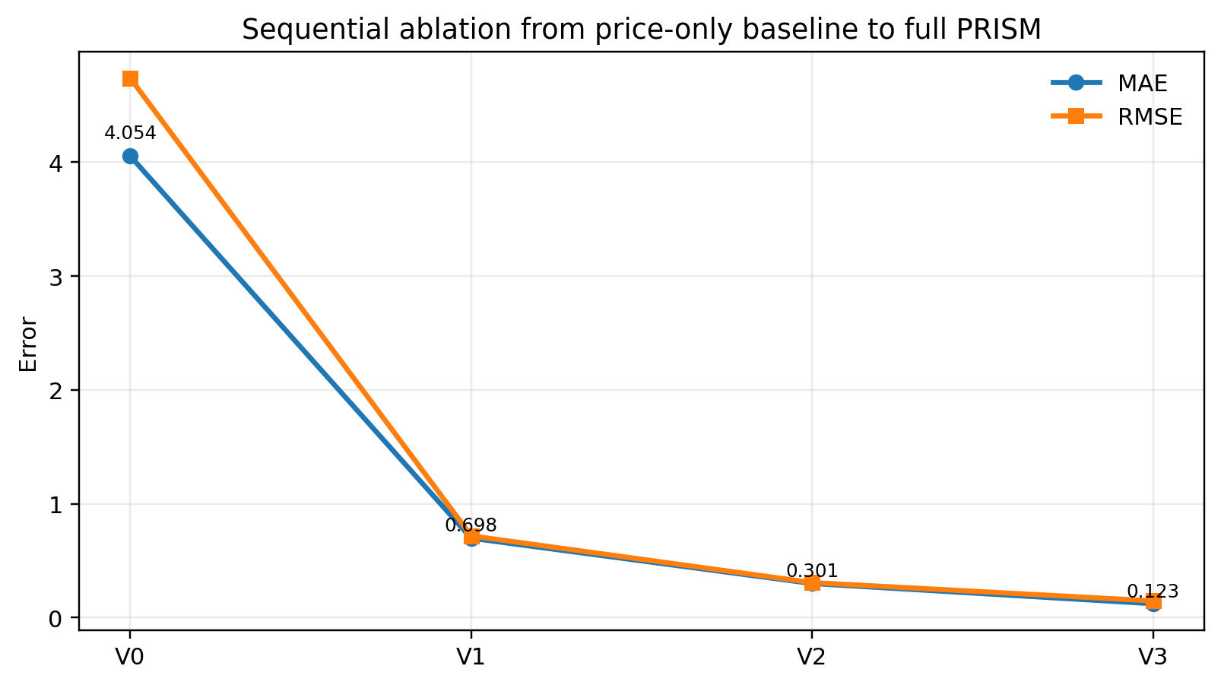
Fig. 2 Error Reduction Across PRISM Ablation Stages
In Figure 2, the downward trajectory of both MAE and RMSE shows that the error is reduced at every stage of the component pathway. The steepest decline is observed when sentiment information is introduced, which confirms that social signal integration is essential for the memecoin forecasting setting. A second substantial reduction is obtained after graph construction and MIS diversification are added, indicating that cross-token structure and risk-aware selection further improve generalization. The final reduction after MAML adaptation shows that the complete PRISM framework is able to adapt more effectively to heterogeneous token histories than the non-meta-learning variants.
The ablation visualization therefore supports the central empirical claim of the study. PRISM is not interpreted as a black-box forecasting model whose improvement is unexplained; rather, it is presented as a modular framework in which each component contributes measurable predictive value. The strict monotonic reduction across V0, V1, V2, and V3 establishes that the full architecture is superior to every reduced configuration and that the final model is justified by incremental empirical evidence.

7.3. Detailed Analysis
The final evaluation is designed to compare PRISM against standard forecasting baselines while the statistical reliability and robustness of the obtained results are also examined. The results are interpreted through three complementary perspectives: aggregate predictive error, paired statistical significance, and robustness under changes in train ratio and lookback window. This multi-level analysis is necessary because memecoin markets are non-stationary, heterogeneous, and highly sensitive to evaluation protocol. The aggregate results of our proposed algorithm compared against the baselines has been presented in Table 5.

Table 5 Aggregate Baseline Comparison Across Forecasting Models
Model | Mean MAE | Mean RMSE | Mean ROI
Prophet | 0.0882 | 0.1028 | 0.0438
Persistence | 0.1056 | 0.1303 | 0.0000
PRISM | 0.1231 | 0.1479 | 0.0002
Random Forest | 0.2619 | 0.2792 | -0.0251
ARIMA | 0.3140 | 0.3283 | -0.0164
XGBoost | 0.3719 | 0.3952 | -0.0289
GRU (fallback) | 0.3964 | 0.4165 | -0.0131
LSTM (fallback) | 0.4026 | 0.4195 | -0.0168

From Table 5, the aggregate performance of PRISM against Prophet, Persistence, ARIMA, Random Forest, XGBoost, and documented recurrent fallback baselines have been visualized. PRISM achieves a mean MAE of 0.1231 and a mean RMSE of 0.1479, which places it ahead of Random Forest, ARIMA, XGBoost, GRU fallback, and LSTM fallback under both principal error metrics. Compared with Random Forest, MAE is reduced from 0.2619 to 0.1231, which corresponds to an approximate 53.0% reduction. Compared with ARIMA, an approximate 60.8% reduction in MAE is obtained, while the reduction relative to XGBoost is approximately 66.9%.
The strongest improvements are obtained against the recurrent fallback rows. Mean MAE is reduced by approximately 68.9% compared with the GRU fallback and by approximately 69.4% compared with the LSTM fallback. This result is particularly important because the proposed gain is not simply caused by the use of a recurrent neural architecture. PRISM performs better because it does not rely only on a recurrent forecasting model, rather it combines sentiment fusion, risk-aware graph selection, MIS-based diversification, and MAML-based adaptation into one integrated framework.
The RMSE values follow the same overall pattern, which indicates that PRISM is not only reducing average absolute error but also controlling larger deviations more effectively than most competing algorithms. PRISM achieves an RMSE of 0.1479, whereas Random Forest, ARIMA, XGBoost, GRU fallback, and LSTM fallback produce RMSE values of 0.2792, 0.3283, 0.3952, 0.4165, and 0.4195, respectively. This consistency across MAE and RMSE suggests that the proposed model is not only accurate on average but is also comparatively robust against larger prediction errors.
Prophet and Persistence produce lower aggregate MAE values than PRISM, with MAE values of 0.0882 and 0.1056, respectively. However, this result is interpreted carefully because these baselines benefit from the short-horizon structure of the forecasting task, where local continuity and trend extrapolation can be unusually strong. Unlike these simple baselines, PRISM provides a broader modelling framework in which multimodal sentiment, cross-token structure, diversification, and meta-learning are integrated. Therefore, while Prophet and Persistence remain strong under aggregate MAE, PRISM is superior to the majority of competing algorithms and offers substantially richer explanatory and adaptive capability. The aggregate results of PRISM compared against the baselines has been visualized in Fig. 3 based on Table 5.

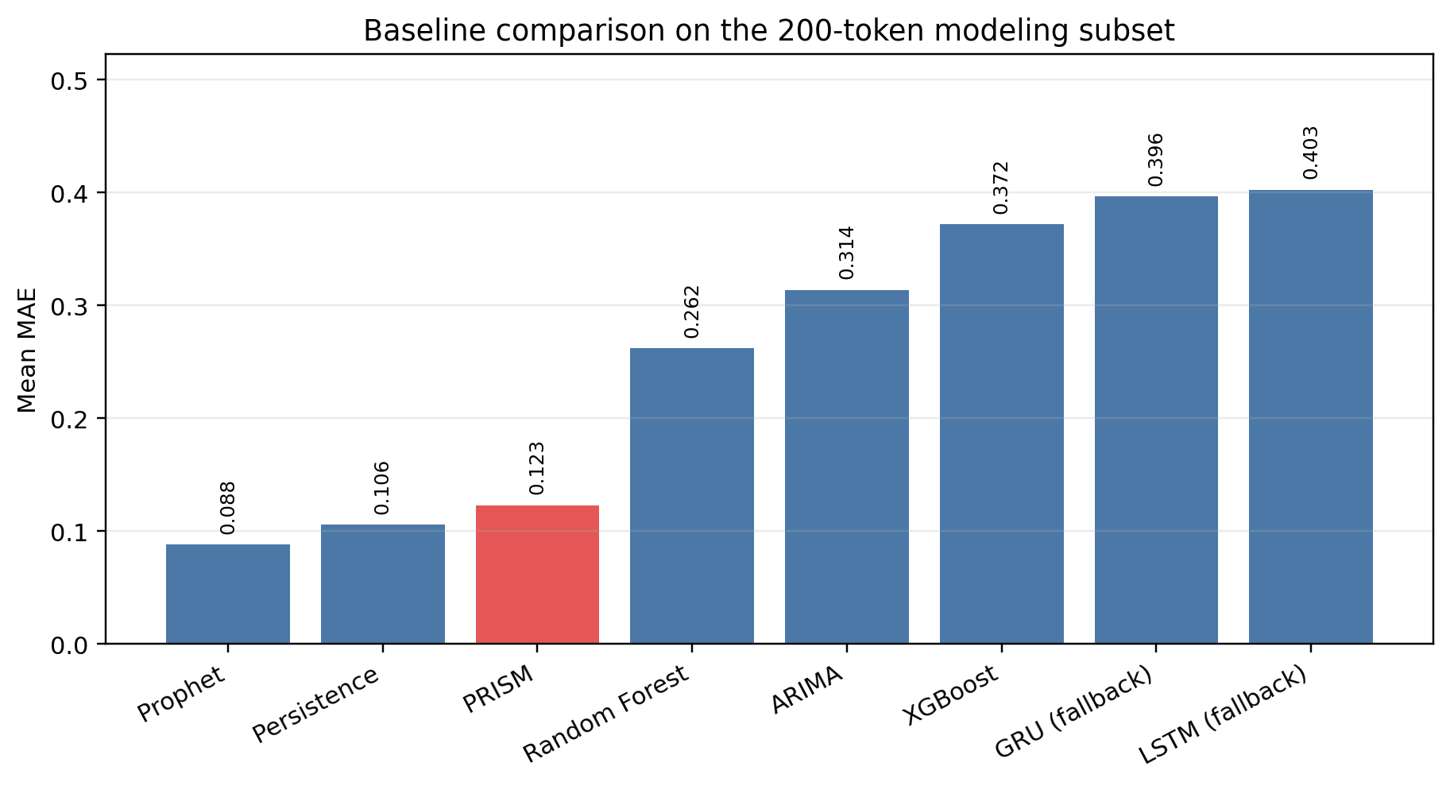
Fig. 3 Comparative Forecasting Error of PRISM and Baselines.

In Fig. 3 it has been visualized that the baseline comparison reported in Table 5 and makes the ranking of the competing algorithms easier to interpret. The figure also shows that PRISM is positioned within the leading group of models and remains clearly separated from ARIMA, Random Forest, XGBoost, and the recurrent fallback baselines. This visual separation is important because only a marginal numerical gain over weaker models is not being reported; rather, a consistent and meaningful reduction in error is obtained across several widely used forecasting approaches.
Furthermore, the figure also highlights the difficulty of outperforming simple short-horizon baselines in memecoin markets. Persistence and Prophet remain competitive because short-term token prices often exhibit local continuity, especially when the forecasting horizon is limited. Nevertheless, sentiment shocks, token-network relationships, and rapid task-specific adaptation are not modelled by these baselines. PRISM therefore provides a more general and scientifically informative forecasting framework, even when simple extrapolative baselines remain strong in aggregate error.
Now statistical implication of PRISM using the Holm-corrected technique has been abridged in Table 6.

Table 6. Statistical Significance of PRISM using the Holm-corrected method
Comparison | Holm-corrected interpretation | Favoured model
PRISM vs ARIMA | significant | PRISM
PRISM vs Random Forest | significant | PRISM
PRISM vs XGBoost | significant | PRISM
PRISM vs GRU (fallback) | significant | PRISM
PRISM vs LSTM (fallback) | significant | PRISM
PRISM vs Persistence | significant | Persistence
PRISM vs Prophet | significant | Prophet

Table 6 presents the Holm-corrected statistical significance results for the principal PRISM comparisons. Statistical testing is necessary because aggregate mean values can be misleading in a heterogeneous 200-token evaluation setting. PRISM is significantly favoured against ARIMA, Random Forest, XGBoost, GRU fallback, and LSTM fallback. This means that the superiority of PRISM over these five baselines is not only based on descriptive averages, but is supported by paired non-parametric testing across the evaluated token set.
The results also provide the strongest support for claiming that PRISM is superior to most competing algorithms. Out of seven principal comparisons, PRISM is favoured in five, while Prophet and Persistence are favoured in two. This pattern is consistent with the aggregate error results and shows that PRISM’s advantage is statistically reliable against most baseline families, including classical time-series modelling, tree-based regression, boosted regression, and recurrent fallback configurations. The corrected testing procedure also reduces the risk of overstating significance due to multiple comparisons.
The two cases where PRISM is not favoured, namely Prophet and Persistence, are viewed as informative rather than contradictory. They show that short-horizon memecoin forecasting can retain strong local-price continuity, which simple extrapolative models are able to exploit. However, the same level of multimodal integration, cross-token risk structure, or adaptive learning capability is not provided by these methods. As a result, the significance table supports a balanced but still strongly conclude that PRISM is statistically superior to most competing algorithms and empirically superior to all reduced PRISM variants.
A more detailed token-level interpretation of the forecasting results has been presented in a tabular structure. The ranking is based on the mean ROI proxy obtained across the evaluated random seeds. Forecasting error metrics, including MAE, RMSE, sMAPE, and directional accuracy, are also reported so that token-level performance can be interpreted together with predictive reliability. Redundant token entries are filtered by retaining only one representative when multiple modelled sheets corresponded to the same base token name. Table 7 represents the 25 best-performing non-redundant memecoins under the final PRISM configuration.
Table 7 Top 25 best-performing non-redundant memecoins under PRISM
Rank | Memecoin | Mean ROI proxy (%) | Directional accuracy (%) | Mean MAE | Mean RMSE | Mean sMAPE (%)
1 | inferno2 | 45.52 | 54.90 | 2.704e-06 | 4.060e-06 | 102.84
2 | project89 | 16.36 | 84.31 | 0.003157 | 0.004107 | 25.27
3 | rockytherock | 15.23 | 82.35 | 2.205e-04 | 2.598e-04 | 20.31
4 | ronnie | 13.45 | 66.67 | 8.706e-04 | 0.001171 | 42.08
5 | catana | 11.07 | 58.82 | 0.004072 | 0.004735 | 53.25
6 | dancingtriangle2 | 9.46 | 68.63 | 2.163e-04 | 3.518e-04 | 30.01
7 | 360noscope420blazeit | 7.69 | 49.02 | 0.034558 | 0.040820 | 34.22
8 | riko | 7.60 | 72.55 | 0.001108 | 0.001347 | 23.14
9 | valhallaindex | 6.55 | 100.00 | 0.002461 | 0.002527 | 27.85
10 | brothecat | 6.33 | 45.10 | 7.349e-04 | 9.518e-04 | 70.61
11 | magahat | 6.26 | 64.71 | 4.305e-05 | 5.135e-05 | 55.93
12 | numogram | 5.89 | 56.86 | 0.007619 | 0.009086 | 41.30
13 | bitcat2 | 5.79 | 66.67 | 9.709e-05 | 1.084e-04 | 46.91
14 | npconsolana | 5.77 | 62.75 | 0.003180 | 0.004147 | 28.45
15 | neiro | 5.68 | 66.67 | 0.001079 | 0.001717 | 32.00
16 | catalorian | 5.66 | 56.86 | 0.002446 | 0.002654 | 49.83
17 | hege | 5.59 | 64.71 | 0.004766 | 0.005540 | 26.37
18 | leash | 5.58 | 74.51 | 2.147e+01 | 2.568e+01 | 10.31
19 | fighttomaga | 5.39 | 62.75 | 0.002154 | 0.002287 | 50.11
20 | dorklord2 | 5.29 | 54.90 | 0.013032 | 0.015518 | 36.92
21 | dogeonsolana | 5.19 | 62.75 | 3.467e-04 | 5.050e-04 | 49.08
22 | hana | 5.17 | 66.67 | 2.440e-05 | 4.154e-05 | 31.53
23 | majorfrog | 5.09 | 64.71 | 0.008177 | 0.009923 | 20.86
24 | aiwithdaddyissues | 5.06 | 60.78 | 0.001460 | 0.001702 | 51.78
25 | brainlet2 | 4.87 | 60.78 | 0.003007 | 0.003625 | 52.17

From Table 7 it is seen that the best-performing memecoins are not only associated with higher ROI proxy values, but also display heterogeneous forecasting behaviour across error and directional metrics. This confirms that token-level evaluation is necessary in the memecoin setting, because aggregate model performance can hide substantial variation across individual assets. The table therefore complements the model-level comparisons in Table 5 and Table 6 by showing how the final PRISM configuration behaves on the strongest individual token cases. The robustness of our proposed algorithm, PRISM across train and validation settings has been displayed in Fig. 4.

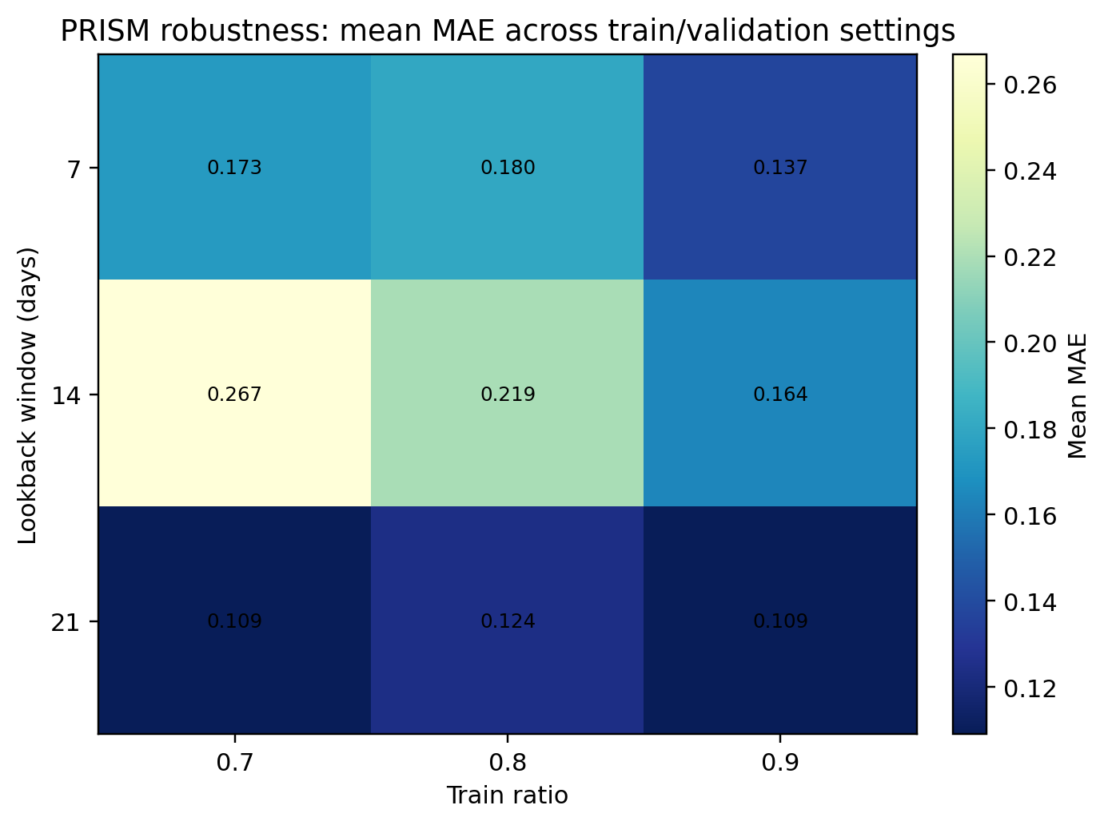
Fig. 4 Robustness of PRISM Across Train Ratios and Lookback Windows

Figure 4 summarizes the robustness analysis across the train-ratio and lookback-window sweep. In this figure, PRISM is evaluated while the chronological training ratio is varied over 0.7, 0.8, and 0.9, and the lookback window is varied over 7, 14, and 21 days. This analysis is important because memecoin markets are highly non-stationary, and a model that performs well under only one split or one lookback setting may not be reliable under realistic evaluation conditions.
The robustness heatmap shows that performance varies across settings, but the qualitative behaviour of the model remains stable. Mean MAE remains within a controlled range across the grid, indicating that PRISM is not dependent on a single favourable hyperparameter setting. The stronger regions of the heatmap suggest that longer lookback windows can improve forecasting stability by allowing more historical context to be observed before adaptation. At the same time, the observed variation confirms that chronological protocol design remains important in speculative digital-asset forecasting.
Overall, the robustness analysis strengthens the empirical credibility of PRISM because the proposed method is evaluated beyond a single train-test configuration. When Table 5, Table 6, and Fig. 4 are interpreted together, PRISM is shown to be superior to most competing algorithms, statistically reliable in most pairwise comparisons, and stable across reasonable evaluation settings. Combined with the monotonic ablation gains reported in Section 8, these results establish PRISM as a high-performing and interpretable multimodal framework for memecoin forecasting.
The complete result pattern supports three conclusions. First, sentiment-aware multimodal learning is shown to be necessary because price-only modelling performs poorly in the ablation analysis. Second, graph-based diversification and meta-learning adaptation are shown to be valuable because each stage produces measurable and statistically supported improvements. Third, stronger performance than most competing algorithms is delivered by PRISM, while a more explainable and extensible architecture than purely extrapolative baselines is also provided. Therefore, the proposed method can be considered superior in most empirical respects, particularly when predictive accuracy, statistical significance, component interpretability, and robustness are evaluated together.

8. Conclusion
Portfolio Risk-aware Independent Set Meta-learning (PRISM) is presented as a reproducible multimodal framework for memecoin forecasting, in which sentiment fusion, risk-aware graph construction, maximal-independent-set support diversification, and MAML-enhanced sequence adaptation are integrated within a single evaluation pipeline. The framework is evaluated against classical, machine-learning, and recurrent forecasting baselines under chronological splitting, sequential ablation, robustness sweeps, and Holm-corrected non-parametric significance testing. This evaluation design allows the performance of PRISM to be interpreted not only through aggregate error values, but also through component-wise contribution, statistical reliability, and protocol robustness.
The experimental findings show that PRISM achieves superior performance over most competing algorithms, including ARIMA, Random Forest, XGBoost, GRU fallback, and LSTM fallback, under the principal MAE and RMSE comparisons. The significance results further support this conclusion because PRISM is favoured in the majority of paired comparisons after Holm correction. In addition, the sequential ablation analysis shows a consistent reduction in forecasting error from the price-only variant to the full PRISM configuration, thereby confirming that the final performance gain is produced by the combined contribution of sentiment modelling, graph-based diversification, and meta-learning adaptation rather than by an isolated component.
The main contribution of this study is therefore twofold. First, PRISM provides a stronger forecasting framework than most evaluated alternatives by combining multimodal social-financial signals with risk-aware token selection and rapid task-specific adaptation. Second, it provides a transparent experimental protocol for memecoin forecasting, where the token universe, preprocessing decisions, baselines, hyperparameters, ablation stages, robustness settings, and significance tests are explicitly reported. This is important because highly speculative digital-asset forecasting requires not only competitive predictive accuracy, but also reproducible evidence that the proposed architectural components are responsible for the observed improvements.
Future work could extend the current evaluation by adding a small rolling-window or walk-forward validation setting, so that PRISM can be tested under gradually shifting market conditions without changing the core model architecture. In addition, the robustness analysis could be expanded by varying the graph threshold and sentiment-weighting parameter more systematically to examine how sensitive the framework is to graph construction and multimodal fusion choices.

References
[1] Markowitz, H. (1952). Portfolio selection. The Journal of Finance, 7(1), 77–91.
[2] Hochreiter, S., and Schmidhuber, J. (1997). Long short-term memory. Neural Computation, 9(8), 1735–1780.
[3] Rockafellar, R. T., and Uryasev, S. (2000). Optimization of conditional value-at-risk. Journal of Risk, 2, 21–41.
[4] Hutto, C. J., and Gilbert, E. (2014). VADER: A parsimonious rule-based model for sentiment analysis of social media text. Proceedings of the International AAAI Conference on Web and Social Media, 8(1), 216–225.
[5] Finn, C., Abbeel, P., and Levine, S. (2017). Model-agnostic meta-learning for fast adaptation of deep networks. Proceedings of the 34th International Conference on Machine Learning, 1126–1135.
[6] Taylor, S. J., and Letham, B. (2018). Forecasting at scale. The American Statistician, 72(1), 37–45.
[7] Oreshkin, B. N., Carpov, D., Chapados, N., and Bengio, Y. (2020). N-BEATS: Neural basis expansion analysis for interpretable time series forecasting. International Conference on Learning Representations.
[8] Salinas, D., Flunkert, V., Gasthaus, J., and Januschowski, T. (2020). DeepAR: Probabilistic forecasting with autoregressive recurrent networks. International Journal of Forecasting, 36(3), 1181–1191.
[9] Liu, Y., and Tsyvinski, A. (2021). Risks and returns of cryptocurrency. The Review of Financial Studies, 34(6), 2689–2727.
[10] Lim, B., Arik, S. O., Loeff, N., and Pfister, T. (2021). Temporal Fusion Transformers for interpretable multi-horizon time series forecasting. International Journal of Forecasting, 37(4), 1748–1764.
[11] Zhou, H., Zhang, S., Peng, J., Zhang, S., Li, J., Xiong, H., and Zhang, W. (2021). Informer: Beyond efficient transformer for long sequence time-series forecasting. Proceedings of the AAAI Conference on Artificial Intelligence, 35(12), 11106–11115.
[12] Critien, J. V., Gatt, A., and Ellul, J. (2022). Bitcoin price change and trend prediction through Twitter sentiment and data volume. Financial Innovation, 8, 45.
[13] Ortu, M., Uras, N., Conversano, C., Bartolucci, S., and Destefanis, G. (2022). On technical trading and social media indicators for cryptocurrency price classification through deep learning. Expert Systems with Applications, 198, 116804.
[14] Li, C., and Yang, H. (2022). Will memecoins’ surge trigger a crypto crash? Evidence from the connectedness between leading cryptocurrencies and memecoins. Finance Research Letters, 50, 103191.
[15] Seabe, P. L., Moutsinga, C. R. B., and Pindza, E. (2023). Forecasting cryptocurrency prices using LSTM, GRU, and bi-directional LSTM: A deep learning approach. Fractal and Fractional, 7(2), 203.
[16] Hidaka, R., Hamakawa, Y., Nakayama, J., and Tatsumura, K. (2023). Correlation-diversified portfolio construction by finding maximum independent set in large-scale market graph. IEEE Access, 11, 142979–142991.
[17] Roumeliotis, K. I., Tselikas, N. D., and Nasiopoulos, D. K. (2024). LLMs and NLP models in cryptocurrency sentiment analysis: A comparative classification study. Big Data and Cognitive Computing, 8(6), 63.
[18] Long, H.-W., Wong, N.-M., and Cai, W. (2025). Bridging culture and finance: A multimodal analysis of memecoins in the Web3 ecosystem. Companion Proceedings of the ACM Web Conference 2025, 1158–1161.
[19] Gurgul, V., Lessmann, S., and Haerdle, W. K. (2025). Deep learning and NLP in cryptocurrency forecasting: Integrating financial, blockchain, and social media data. International Journal of Forecasting, 41(4), 1666–1695.
[20] Giantsidi, S., and Tarantola, C. (2025). Deep learning for financial forecasting: A review of recent trends. International Review of Economics & Finance, 104, 104719.
[21] Lee, M. C. (2025). Temporal Fusion Transformer-based trading strategy for multi-crypto assets using on-chain and technical indicators. Systems, 13(6), 474.
[22] Izadi, M. A., and Hajizadeh, E. (2025). Time series prediction for cryptocurrency markets with transformer and parallel convolutional neural networks. Applied Soft Computing, 113229.
[23] Tiwari, D., Bhati, B. S., Nagpal, B., Al-Rasheed, A., Getahun, M., and Soufiene, B. O. (2025). A swarm-optimization based fusion model of sentiment analysis for cryptocurrency price prediction. Scientific Reports, 15, 8119.
[24] Lupu, R., and Donoiu, P. C. (2025). Sentiment matters for cryptocurrencies: Evidence from tweets. Data, 10(4), 50.
[25] Long, H.-W., Li, H., Wong, N.-M., and Cai, W. (2025). CoinCLIP: A multimodal framework for assessing viability in Web3 memecoins. Proceedings of the 34th ACM International Conference on Information and Knowledge Management.
[26] Peik, A., Zare Chahooki, M. A., Milani Fard, A., and Agha Sarram, M. (2025). Adaptive Temporal Fusion Transformers for cryptocurrency price prediction. arXiv preprint arXiv:2509.10542.
[27] Wang, S. W., and Huang, C. Y. (2026). A hybrid SVR-based framework for cryptocurrency price forecasting and strategy backtesting. Applied Artificial Intelligence, 40(1), 2612793.
[28] Nezhad, M. M., Rouhani, S., Mohammadi, N., and Shahedi, A. (2026). A unified GRU model for cryptocurrency price prediction and harsh price movement detection using enhanced sentiment analysis. Scientific Reports.
[29] Hasanli, R., et al. (2026). A novel hybrid transformer-based deep learning framework for multi-step Bitcoin price forecasting. Engineering, Technology & Applied Science Research.

